Student Interest Survey: Help Your Teacher Get to Know You
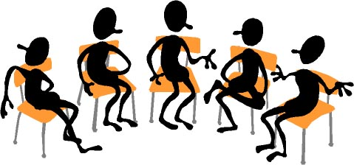

- What is your full name? _____________________________________________________________________
- What do you like to be called? ________________________________________________________________
- How old are you? ______________________
- When is your birthday? _________________
- Who do you live with? ______________________________________________________________________
- How do you get home in the afternoon? ________________________________________________________
- Who is home when you get there? ____________________________________________________________
- What do you do after school? ________________________________________________________________
- Do you have any brothers or sisters that go to this school? YES NO
If yes, please list their names and grades:

Name Grade

___________________________________ ____________
___________________________________ ____________
___________________________________ ____________
- Do you have any brothers or sisters at other schools in the county? YES NO
If yes, please list their names and grades:
Name Grade
___________________________________ ____________
___________________________________ ____________
___________________________________ ____________

Student Interest Survey: Help Your Teacher Get to Know You

- What is your favorite thing to learn about in school? ______________________________________________
- What subject is the biggest challenge? _________________________________________________________
- What subject is your least favorite? ____________________________________________________________
- What is something that you’re good at (Everyone is good at something!)? _____________________________
_________________________________________________________________________________________
- Finish the sentences: “School would be better if… _______________________________________________
- “On the weekends, I like to… _________________________________________________________________
- “Sometimes I worry about… __________________________________________________________________
- Write two words that describe you: 1. ___________________________ 2. __________________________
- What time do you usually go to sleep during the school year? _______________________________________
- What is your favorite restaurant? _____________________________________________________________
- If I went there, what should I order? ________________________________________________________
- If you could take a trip anywhere, where would you go? ___________________________________________
- What is your favorite sport? __________________________________________________________________
- What is your favorite food? __________________________________________________________________
- What is your favorite candy? _________________________________________________________________
- Who is your favorite musician? _______________________________________________________________
- What is your favorite TV show? _______________________________________________________________
- Is there anything else I should know about you? (Anything from “I’m shy,” to “I have bad eyesight, and I need to sit up front to see.” _______________________________________________________________________
_________________________________________________________________________________________

- Tell me a little about your summer. You could share details about a trip, how you spent your time, etc.

____________________________________________________________________________________________________________________________________________________________________________________________________________________________________________________________________________________________________________________________________________________________________

