Working Above the Line: A Classroom Discipline Plan for Keeping Students on Track
- Hold a conversation with students about what it means to work Above and Below the Line. Your conversation will be based on the grade and maturity of your students. It will also support the rules of your classroom AND help students learn more about specific behaviors of successful people. See below for one possibility:
- What is working “Above the Line”? When you are working “Above the Line” you are respecting yourself, your teachers, and other fellow students. You are following school rules, using class time productively, working well with others, and giving your best effort to complete assignments.
- What is working “Below the Line”? When you are working “Below the Line” you are disrespecting yourself, your teachers, or other students. You are not learning or respecting others’ rights to learn.
- Who decides if I am working “Above the Line” or “Below the Line”? You do! You are responsible for your actions. I cannot make you work above the line; however, I can help you find ways to make better choices. If you are working “Below the Line” it is up to you to fix it with or without my help.
- What can I expect if I am working “Above the Line”? If you are working “Above the Line” you will have better grades, gain self-respect, earn (Insert appropriate positive consequences), and earn more trust from your teachers and possibly your peers, as well.
- What can I expect if I am working “Below the Line”? If you are working “Below the Line” your grades will suffer, and you will fall behind academically. You will earn referrals and lose privileges. Your teachers will lose trust in you, and your peers may not want to work with you.

- Create a visual representation of Working Above and Below the Line. It could look something like this:
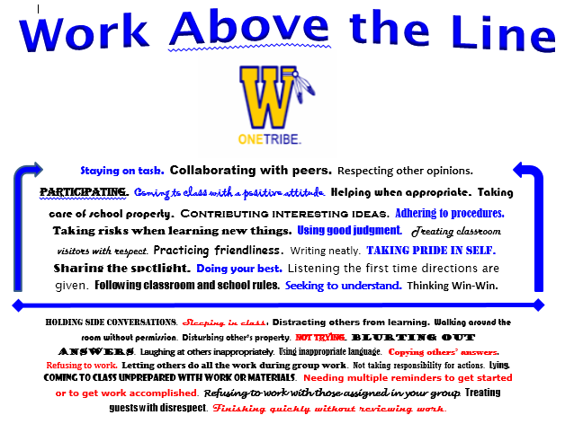

- Help students understand how PROGRESSIVE DISCIPLINE ties into Working Above and Below the Line:
- Step ONE: Verbal or non-verbal warning – Teacher can alert the student and simply ask, “Are you above or below the line right now? Teacher could also say student’s name and point to the Above the Line section of the poster.
- Step TWO: Second warning - Give the student a card that asks him/her to get it together. This is the student’s final warning before speaking with the teacher privately. See card below that could be laminated so you can write a student’s name on it.

- Step THREE: Teacher takes action. Go to student’s desk and take the card from him or her, signifying that he/she needs to see you before leaving class (This is a procedure to teach!). Teacher may write the student’s name on it to keep track. This action constitutes a “teacher/student conference” in PROGRESSIVE DISCIPLINE. If the student behaves after teacher takes the card, the discipline does not progress – just a talk to figure out what was going on with the student and to ask for better work the next day. If, however, the student becomes enraged or further disrupts others, the talk will also include notice of communication with the parent and issuance of a detention, perhaps. Make note of how far things progressed on your Progressive Discipline Chart at some point that day:
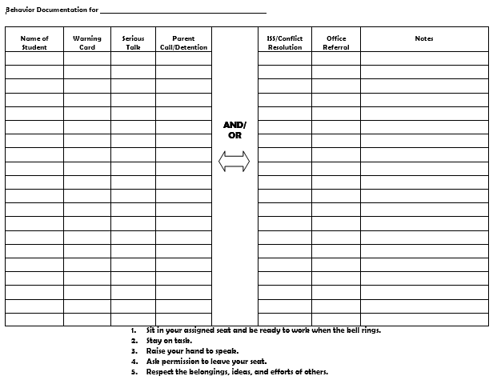

- Step THREE continued: Teacher takes action. If the student continues to work below the line, you let the student know that during your discussion and issue a detention at the end of class. When the student serves the detention, you could ask the student to fill out this form below before he/she leads a conversation with you about what’s going on. This form can also serve as documentation to share with the parent.
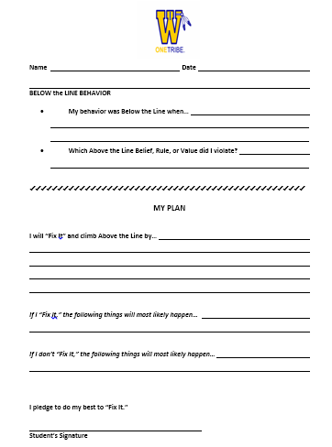

Other ideas:
- You may wish to use this idea with your whole class to remind them of appropriate behavior during class discussions or group work activities. The class, as whole, can earn tallies each day, set goals to improve, and earn chances for meaningful rewards. Just make this chart and use it daily!
Our Behavior | Monday | Tuesday | Wednesday | Thursday | Friday | GOALS
Above The Line
Working Towards The Line
Below The Line

Wendy Waller, Wicomico Public Schools, 2014 – Adapted from http://www.top20training.com/line.php

