Additional Classroom Interventions to Try

In no particular order…
Seat change
Assigning jobs, class helper
Point charts
Start every day with ten points (participation)
Private consultation in the hallway
Redirect through positive ripple effect (compliment those doing the right things)
See me after class (avoids direct conflict and allows cool-off time)
THE LOOK - https://www.edutopia.org/blog/new-teachers-how-develop-look-rebecca-alber
Post It note redirection (avoids confrontation)
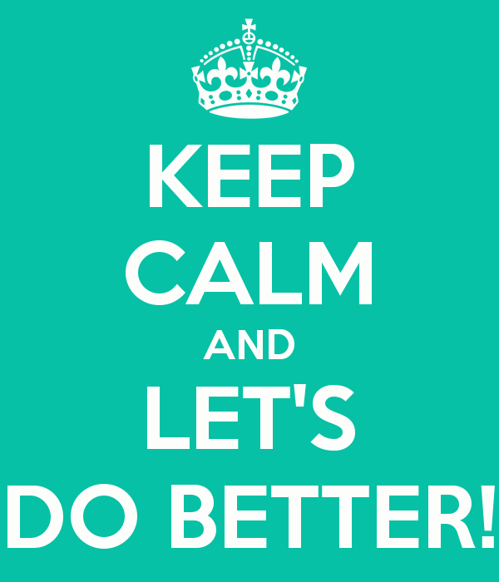
Time out/break with another team member
Three strikes and you’re out (strikes on board)
Send student to do an errand to another teacher
Go over expectations every day for at least three weeks
Specific, verbal praise
PBIS Incentives reminders
School PBIS bucks or tokens
Assigned seats
Redirection to today’s agenda on the board
Point to expectations poster
Plan transitions carefully
Use a timer for EVERYTHING. Remind kids how much time they have left.
Explain expectations ahead of time, and project them using PowerPoint
Planned ignoring (Ignore until they do what you expect… raise hand, etc.)
Walk around the room and monitor
Check for understanding before you have kids work independently
Call home for POSITIVE behaviors!
Have students repeat directions back to the class
Clap back
Give me five

Thanks to Tara Elliott as SMS for sharing these ideas!

