[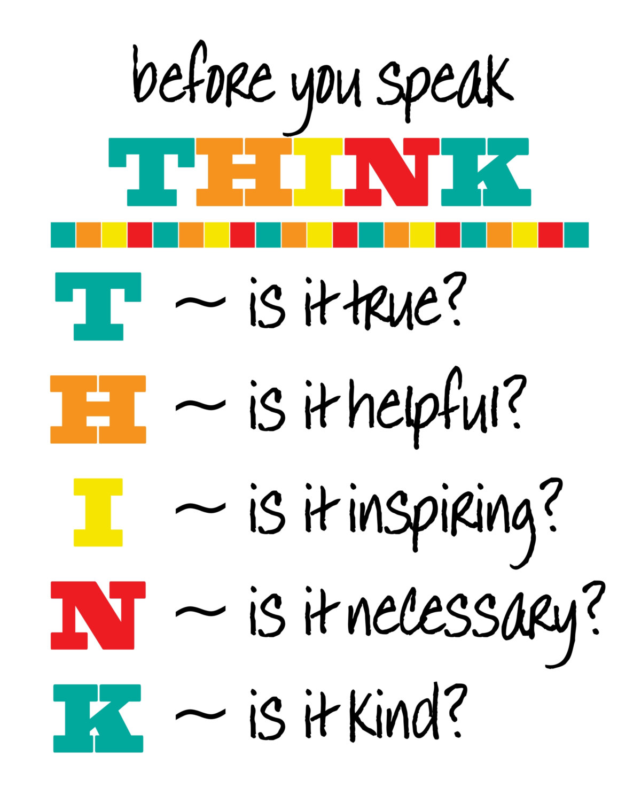](https://www.google.com/url?sa=i&rct=j&q=&esrc=s&frm=1&source=images&cd=&cad=rja&uact=8&ved=0CAcQjRxqFQoTCLeYg6OWz8gCFYJxPgodrnQAFg&url=https://www.etsy.com/listing/158131471/classroom-poster-instant-download-before&bvm=bv.105454873,d.cWw&psig=AFQjCNG0ZoMzD160jcmAqPCLiuHNpCOP3w&ust=1445366041514498)