Love and Logic Language

I Can’t Do It!
This Photo by Unknown Author is licensed under CC BY-SA-NC
STUDENT: “I can’t do it! It’s too hard!”
TEACHER: “Aren’t you glad I don’t believe that?”

Lost Homework
STUDENT: “I don’t have my homework. I lost it.”
TEACHER: “That’s really sad, but the good news is that I’ll be happy to accept it tomorrow for reduced credit.”

The Problem Chair
TEACHER (with a calm whisper): “I have another chair for you right here. That chair you’ve been using always has been a problem.
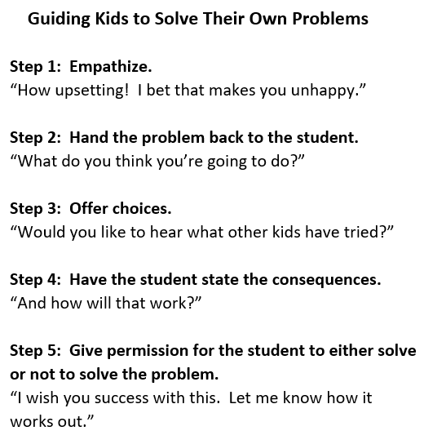
STUDENT: “Geeze! I’m not doing anything wrong!”

TEACHER (with a friendly grin): “I know. It’s that chair. It’s not your fault. This chair over by me is way better. Thanks.”

STUDENT: “This is so dumb! Why should I move?”

TEACHER: “I agree. I think the custodian should take that chair out to the dumpster. It was a problem for a few students last year, too.”

I Believe in You
TEACHER: “I believe in you so much that that I feel the need to nag.”
STUDENT: (Rolls eyes)
TEACHER: “Would it be okay if I occasionally nagged you by whispering, ‘How can I help?’”

Refusing to Work
Teaching with Love and Logic by Jim Fay and Charles Fay, 2016, 2nd Edition
STUDENT: (Is sitting in class refusing to work.)
TEACHER (whispers): I can see that you are learning in a different way today.”
STUDENT: “I ain’t learning nothin’.”
TEACHER (smiling and continuing to whisper): “I’m such a great teacher that students can learn even when they aren’t doing any work. The sad thing is they have nothing to turn in for a grade. Just let me know how I can help.”

Not Following Rules
STUDENT: (Not following the rules during a game.)
TEACHER: “There are two ways to enjoy the game. One, is by playing it, and the other one, is by watching it. Which would you rather do?”
STUDENT: “Well, I’m not the only one…”
TEACHER (with empathy): “Oh, man. It looks like you’ll be watching.”
STUDENT: “That’s not fair!”
TEACHER: “I bet it looks that way. You may return to the game when I no longer have to worry about cheating and arguing.”

Cell Phones/Gum/Drinks, etc.
STUDENT: “We get to … in our other classes.”
TEACHER (smiling): “Thank you for letting me know. And what is the procedure in this room?”

