[](http://www.google.com/url?sa=i&rct=j&q=&esrc=s&frm=1&source=images&cd=&cad=rja&uact=8&ved=0CAcQjRxqFQoTCJfRlcG-iMgCFcNWPgodDvkMdA&url=http://picshype.com/visualization-board/blanche's-vision-board/54855&psig=AFQjCNGfqd4nDYukcTvE40J7CkQ-gqtz4g&ust=1442937230851433)[](http://www.google.com/url?sa=i&rct=j&q=&esrc=s&frm=1&source=images&cd=&cad=rja&uact=8&ved=0CAcQjRxqFQoTCMLp2eu9iMgCFchxPgodtNUHqw&url=http://www.sheknows.com/living/articles/815741/vision-boards-for-the-school-year-1&psig=AFQjCNHPXuPhIEhbCgnG6auGlRYftDLHTw&ust=1442937126898327)[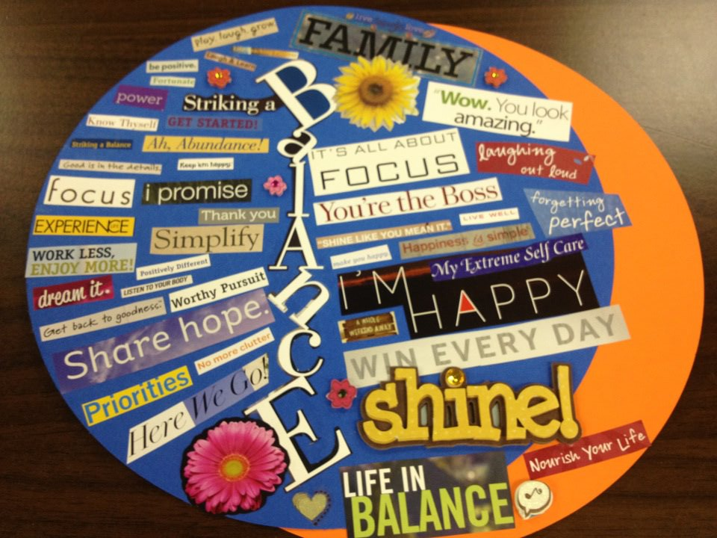](http://www.google.com/url?sa=i&rct=j&q=&esrc=s&frm=1&source=images&cd=&ved=0CAcQjRxqFQoTCLaSvLu9iMgCFUTzPgodOqMOwQ&url=http://yougotjoy.com/?p=1472&psig=AFQjCNFhCo1TFlCVYNJEGT_g3kklgrwL-g&ust=1442936429992116)[](http://www.google.com/url?sa=i&rct=j&q=&esrc=s&frm=1&source=images&cd=&ved=0CAcQjRxqFQoTCMne6pG9iMgCFUtpPgod5TICBA&url=http://phazesfitness.com/?page_id=618&psig=AFQjCNFhCo1TFlCVYNJEGT_g3kklgrwL-g&ust=1442936429992116)[](http://www.google.com/url?sa=i&rct=j&q=&esrc=s&frm=1&source=images&cd=&cad=rja&uact=8&ved=0CAcQjRxqFQoTCMne6pG9iMgCFUtpPgod5TICBA&url=http://phazesfitness.com/?page_id=618&psig=AFQjCNFhCo1TFlCVYNJEGT_g3kklgrwL-g&ust=1442936429992116)

[](http://www.google.com/url?sa=i&rct=j&q=&esrc=s&frm=1&source=images&cd=&cad=rja&uact=8&ved=0CAcQjRxqFQoTCMne6pG9iMgCFUtpPgod5TICBA&url=http://phazesfitness.com/?page_id=618&psig=AFQjCNFhCo1TFlCVYNJEGT_g3kklgrwL-g&ust=1442936429992116)

[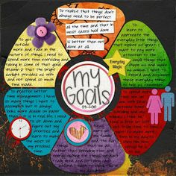](https://www.google.com/url?sa=i&rct=j&q=&esrc=s&frm=1&source=images&cd=&cad=rja&uact=8&ved=0CAcQjRxqFQoTCOKx1-G8iMgCFUQXPgod-MULCQ&url=https://www.pinterest.com/alejandraad/visiondream-board/&psig=AFQjCNFhCo1TFlCVYNJEGT_g3kklgrwL-g&ust=1442936429992116)[](http://www.google.com/url?sa=i&rct=j&q=&esrc=s&frm=1&source=images&cd=&ved=0CAcQjRxqFQoTCKWl8sK8iMgCFYpwPgodJtoH4Q&url=http://www.brigeeski.com/blog/2014-dream-board/&psig=AFQjCNFhCo1TFlCVYNJEGT_g3kklgrwL-g&ust=1442936429992116)[](https://www.google.com/imgres?imgurl=http://www.williamshaker.com/wp-content/uploads/2013/01/Vision-Board.jpg&imgrefurl=http://www.williamshaker.com/how-to-create-a-vision-board-and-live-your-dreams/&h=347&w=582&tbnid=n9wLov1119i_0M:&docid=-IpaEMUqcIIWMM&ei=7SQAVp2cF8W3-QHh95_YBw&tbm=isch&ved=0CCsQMygOMA5qFQoTCN3G3Ju7iMgCFcVbPgod4fsHew&biw=1366&bih=650)[](http://www.google.com/url?sa=i&rct=j&q=&esrc=s&frm=1&source=images&cd=&cad=rja&uact=8&ved=0CAcQjRxqFQoTCNa6oc-7iMgCFQQVPgodkhQBqg&url=http://womenonthefence.com/2012/01/09/how-to-make-a-vision-board/&psig=AFQjCNFhCo1TFlCVYNJEGT_g3kklgrwL-g&ust=1442936429992116)[](https://www.google.com/url?sa=i&rct=j&q=&esrc=s&frm=1&source=images&cd=&cad=rja&uact=8&ved=0CAcQjRxqFQoTCILy6d27iMgCFYE_PgodHjEHQQ&url=https://cbwentworth.wordpress.com/tag/dream-board/&psig=AFQjCNFhCo1TFlCVYNJEGT_g3kklgrwL-g&ust=1442936429992116)